
Make this the ultimate guide for your daily learning goals.
Class & Study Schedule
Time | Mon | Tue | Wed | Thur | Fri
00:00 - 00:00 | Your first subject |  | Review your to-do list |  | Choose a recharge day
00:00 - 00:00 |  | Reading Break
00:00 - 00:00
NOON | LUNCH | LUNCH | LUNCH | LUNCH | LUNCH
00:00 - 00:00 |  |  |  |  | self-care time
00:00 - 00:00 |  |  | Focus Time
00:00 - 00:00 | Your last subject for the day |  |  |  | Block out time for tasks /Pomodoro method
00:00 - 00:00 |  | Have a break |  | week's to-do list
00:00 - 00:00 | Check-in w groupmates |  | Exam Prep Zone |  | Reward yourself

Daily Overview

How are you feeling today? Add an icon.
 |  |  | 
Today's motivation in 5 icons or less:
 |  |  |  |  | 

Checklist
PRIORITIES | TASKS
Priority 1 | Input tasks here  Arrange tasks according to the order of priority  Update the list daily  Be specific
Priority 2 | Note another task
Priority 3 | Add more

Progress Chart
TASK & DEADLINE | PREPARING | IN-PROGRESS | HALFWAY | WRAPPING UP | NOTES
Organize materials Due on: Nov 20, 2030 |  |  |  |  | Date completed: Nov 19, 2030
Task 2  Add a due date |  |  |  |  | Add more rows as needed

Exam or Report Preparation

Name of Subject: | Specify here
Day of Preparation: | Day 1 of 14
Coverage: | Specific pages from your textbook or sections of your class syllabus
Date of exam or report: | Jan 13, 2030

TITLE OF YOUR TOPIC | This could be a chosen or assigned topic.
SUBTOPICS | These are the main ideas or points of discussion. You can also input a general outline here.
WORDS TO REMEMBER | - New word - include a brief definition, a quote on how it was used, or your own explanation.  - Add another word and definition here.
MILESTONES | I finished taking notes from all my references.  Add more milestones and check them off as you go!
RESOURCES | - Primary reference  - Secondary reference  - Add hyperlinks to your online sources  - Add more references here
ADDITIONAL NOTES | Add your thoughts here after completing this section of the study plan. You can also add icons or photos if you run out of words - or just for fun!  

Note to Self

You can use this part for tasks to carry over for the next day or a quick reflection on what you were able to accomplish for today.

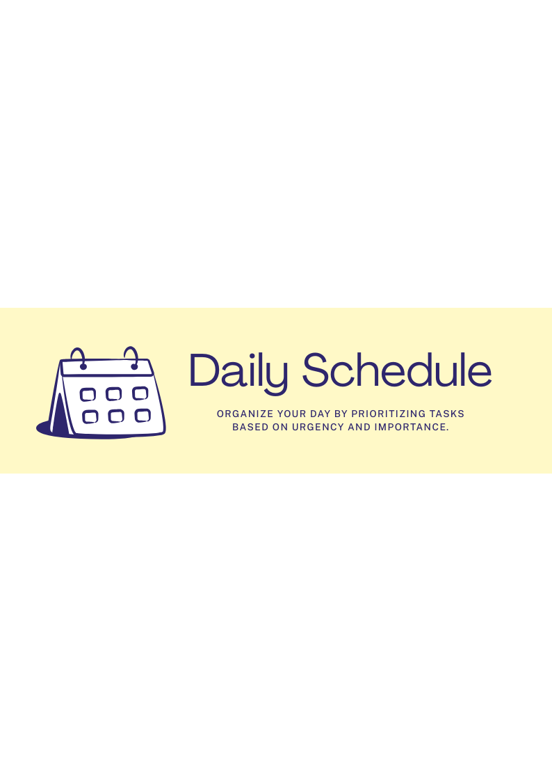
Overview
Date: Jan 31, 2030
 | Urgent | Not urgent
Important | Do first | Plan
 | Add tasks that require immediate attention.  Focus on items that directly impact your goals or responsibilities. | List tasks that involve strategic planning or deep work.  These require thoughtful effort, not immediate action.
Not important | Delegate | Eliminate
 | List tasks that are not critical to your role.  These can be reassigned without impacting key outcomes. | Identify tasks that don’t contribute to your immediate or long-term goals.  Eliminating these will help you focus on what matters most.


To-Do
Canva tips:
- Use = (equal sign) to explore formulas. Generate complex formulas using simple instructions with Magic Formulas.
- Italicized entries contain formulas. Use as is or customize them as needed.
- To reorder data, highlight the cells and select Sort on the toolbar. Use the icons that appear on the headers to sort by Ascending or Descending order.
- Select Actions to add date pills and dropdowns, and unlock more features!

